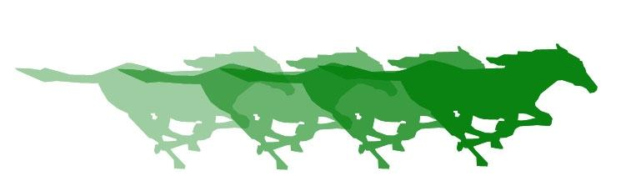
Costa Mesa High School Foundation

The Costa Mesa High School Foundation
is accepting Grant Requests
for the 2019-2020 School Year.

The Grant Applications can be found below or downloaded from the School Loop Foundation Page: http://cmhs.nmusd.us/cmhsfoundation

Deadline for Grant Applications is 5:00 pm

Tuesday April 30, 2019

Applications must be emailed in PDF format to Jake Haley (jhaley@nmusd.us) and Debbie Krohnfeldt (dkrohnfeldt@nmusd.us)

All requests must include quotes from District Approved Vendors. See Gloria Rios with questions.

Costa Mesa High School Foundation
Grant Request Form

Deadline for submission of grant request form is Tuesday, April 30, 2019 at 5:00 pm. Grants must be submitted to Jake Haley (jhaley@nmusd.us) and Debbie Krohnfeldt (dkrohnfeldt@nmusd.us) in PDF format.

Applicant Name:  Department/Grades: |  | Total Amount Requested:

Project Title:

Purpose of Project: Please include the following information in your description:
- A brief background/statement of need
- How this project will enhance or supplement existing resources/instruction
- Number of students impacted
- How long the materials are anticipated to last
- Whether this project supports a new program or provides ongoing support for an existing program

How will you measure the success of your project?
Proposed Project Budget: Including tax and shipping (attach copies of quotes). Requests for conference/staff development/field trips please include registration, transportation, lodging, substitutes, etc. Requests for software or electronic devices must be cleared with the Ed Tech department (edtech@nmusd.us)

Overall Budget: (Insert additional rows as needed)
Category | Amount | Description
GRAND TOTAL

Supplies: (Insert additional rows as needed)
ITEM | DESCRIPTION | Cost per Item | # of Items | Total
 |  | Subtotal
 |  | Tax & Shipping (Estimate 18% for both)
 |  | GRAND TOTAL

A follow-up report for funded requests must be emailed to the CMHS Foundation (dkrohnfeldt@nmusd.us) by January 31, 2020.

Applicant’s Signature |  | Department Chair Signature

